Math 4 Name_______________________________
3-5 Adding and Subtracting Rational Expressions Date________

Learning goal:
I can manipulate rational expressions into useful equivalent forms by simplifying, adding, subtracting, multiplying, and dividing.

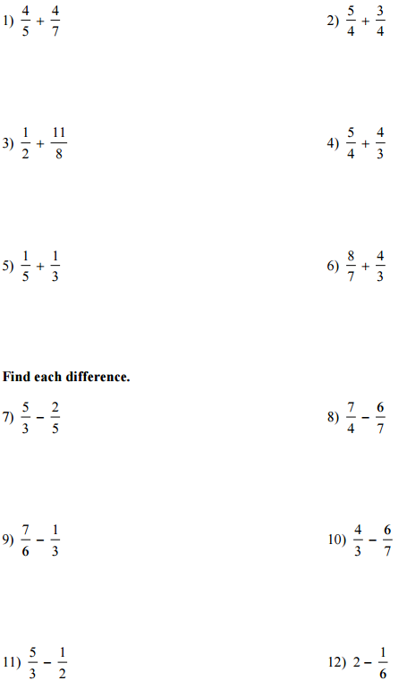
Add and simplify the following fractions.

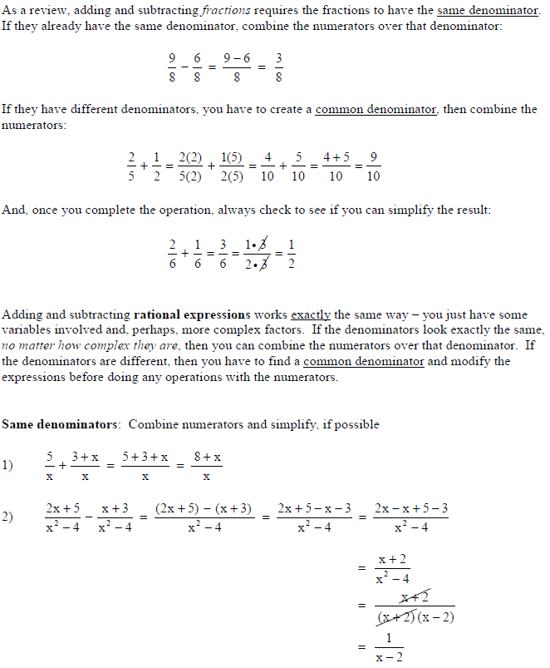
Adding and Subtracting Rational Expressions

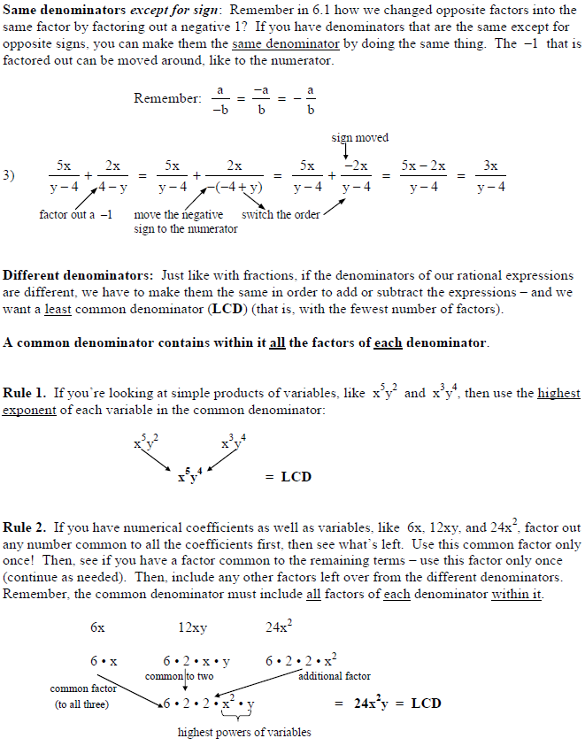

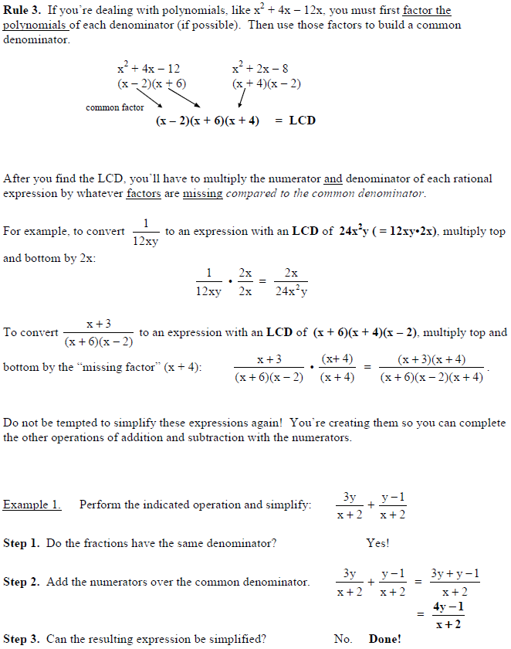

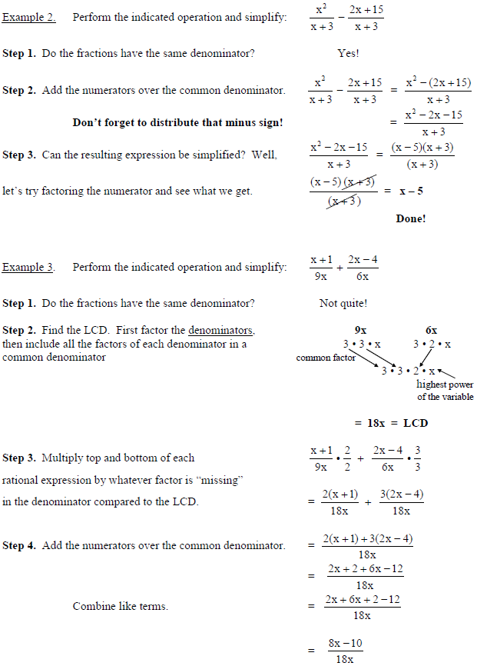

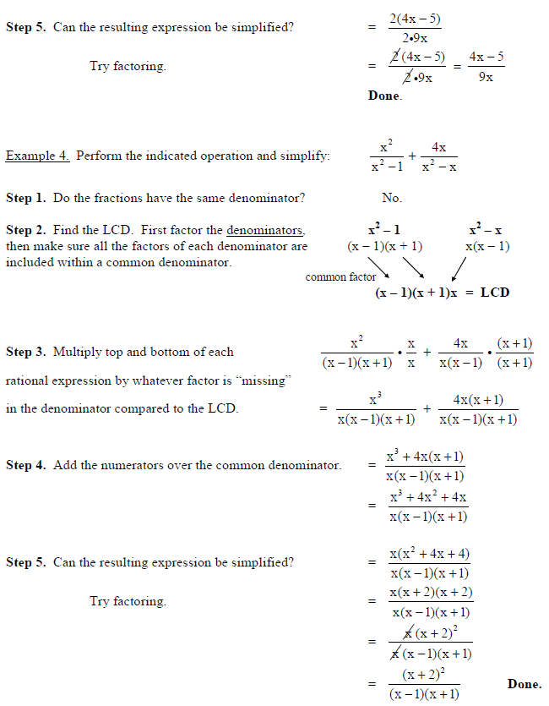

Practice Problems – Show work on a separate sheet of paper!

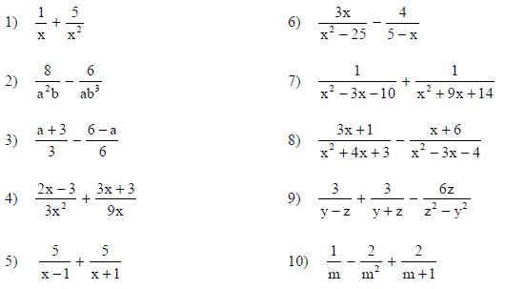
Add, subtract and simplify if possible.

